**Linked list Data Structure**

**A linked list is a linear data structure** that includes a **series of connected nodes.** Here, each node stores the **data** and the **address** of the next node. For example,

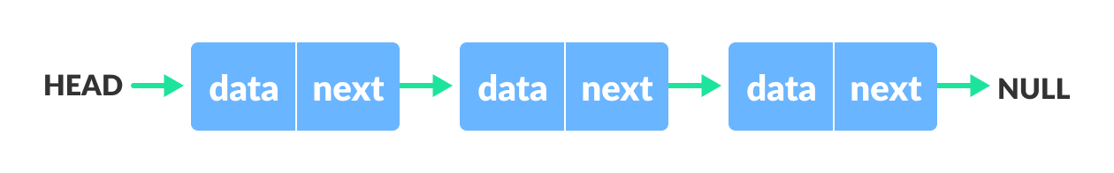**Linked list Data Structure**

You have to start somewhere, so **we give the address of the first node a special name called HEAD.** Also, the **last node in the linked list can be identified because its next portion points to NULL.**

Linked lists can be of multiple types: **singly**, **doubly**, and **circular linked list**. In this article, we will focus on the **singly linked list**. To learn about other types, visit [Types of Linked List](https://www.programiz.com/dsa/linked-list-types).

**Note:** You might have played the game Treasure Hunt, where each clue includes the information about the next clue. That is how the linked list operates.

**Representation of Linked List**

Let's see how each node of the linked list is represented. Each node consists:

* **A data items**
* **An address of another node**

**Linked List Complexity**

Time Complexity

|  |  |  |
| --- | --- | --- |
|  | Worst case | Average Case |
| **Search** | O(n) | O(n) |
| **Insert** | O(1) | O(1) |
| **Deletion** | O(1) | O(1) |

# Linked List Operations: Traverse, Insert and Delete

There are various linked list operations that allow us to perform different actions on linked lists. For example, the insertion operation adds a new element to the linked list.

Here's a list of basic linked list operations that we will cover in this article.

* [Traversal](https://www.programiz.com/dsa/linked-list-operations#traverse) - **access each element of the linked list**
* [Insertion](https://www.programiz.com/dsa/linked-list-operations#add) - adds a new element to the linked list
* [Deletion](https://www.programiz.com/dsa/linked-list-operations#delete) - removes the existing elements
* [Search](https://www.programiz.com/dsa/linked-list-operations#search) - find a node in the linked list
* [Sort](https://www.programiz.com/dsa/linked-list-operations#sort) - sort the nodes of the linked list

Before you learn about linked list operations in detail, make sure to know about [Linked List](https://www.programiz.com/dsa/linked-list) first.

### Things to Remember about Linked List

* head points to the first node of the linked list
* next pointer of the last node is NULL, so if the next current node is NULL, we have reached the end of the linked list.

### 1. Insert at the beginning

* Allocate memory for new node
* Store data
* Change next of new node to point to head
* Change head to point to recently created node

### 2. Insert at the End

* Allocate memory for new node
* Store data
* Traverse to last node
* Change next of last node to recently created node

### 3. Insert at the Middle

* Allocate memory and store data for new node
* Traverse to node just before the required position of new node
* Change next pointers to include new node in between

## Delete from a Linked List

You can delete either from the beginning, end or from a particular position.

### 1. Delete from beginning

* Point head to the second node

### 2. Delete from end

* Traverse to second last element
* Change its next pointer to null

### 3. Delete from middle

* Traverse to element before the element to be deleted
* Change next pointers to exclude the node from the chain

**Search an Element on a Linked List**

You can search an element on a linked list using a loop using the following steps. We are finding item on a linked list.

* **Make head as the current node.**
* **Run a loop until the current node is NULL because the last element points to NULL.**
* In each iteration, **check if the key of the node is equal to item.** If it the key matches the item, return true otherwise return false.

**Sort Elements of a Linked List**

We will use a simple sorting algorithm, [Bubble Sort](https://www.programiz.com/dsa/bubble-sort), to sort the elements of a linked list in ascending order below.

1. Make the head as the current node and **create another node index for later use.**
2. If head is null, return.
3. Else, run a loop till the last node (i.e., NULL).
4. In each iteration, follow the following step 5-6.
5. **Store the next node of current** in index.
6. **Check if the data of the current node is greater than the next node.** If it is greater, swap current and index.

# Types of Linked List - Singly linked, doubly linked and circular

Before you learn about the type of the linked list, make sure you know about the [LinkedList Data Structure](https://www.programiz.com/dsa/linked-list).

There are three common types of Linked List.

1. [Singly Linked List](https://www.programiz.com/dsa/linked-list-types#singly)
2. [Doubly Linked List](https://www.programiz.com/dsa/linked-list-types#doubly)
3. [Circular Linked List](https://www.programiz.com/dsa/linked-list-types#circular)

## Singly Linked List

It is the most common. Each node has data and a pointer to the next node.



**Doubly Linked List**

We add a pointer to the previous node in a doubly-linked list. Thus, we can go in either direction: forward or backward.

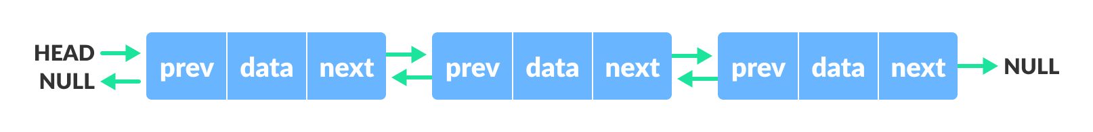

**Circular Linked List**

A circular linked list is a variation of a linked list in which the last element is linked to the first element. This forms a circular loop.

**Circular linked list**

A circular linked list can be either singly linked or doubly linked.

* for singly linked list, next pointer of last item points to the first item
* In the doubly linked list, prev pointer of the first item points to the last item as well.